**Importing the nodes:**

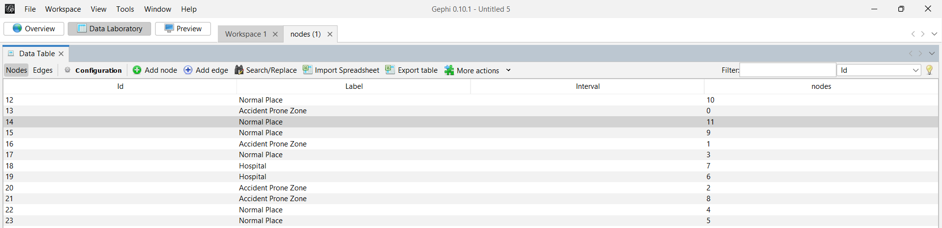

**Importing the edges:**

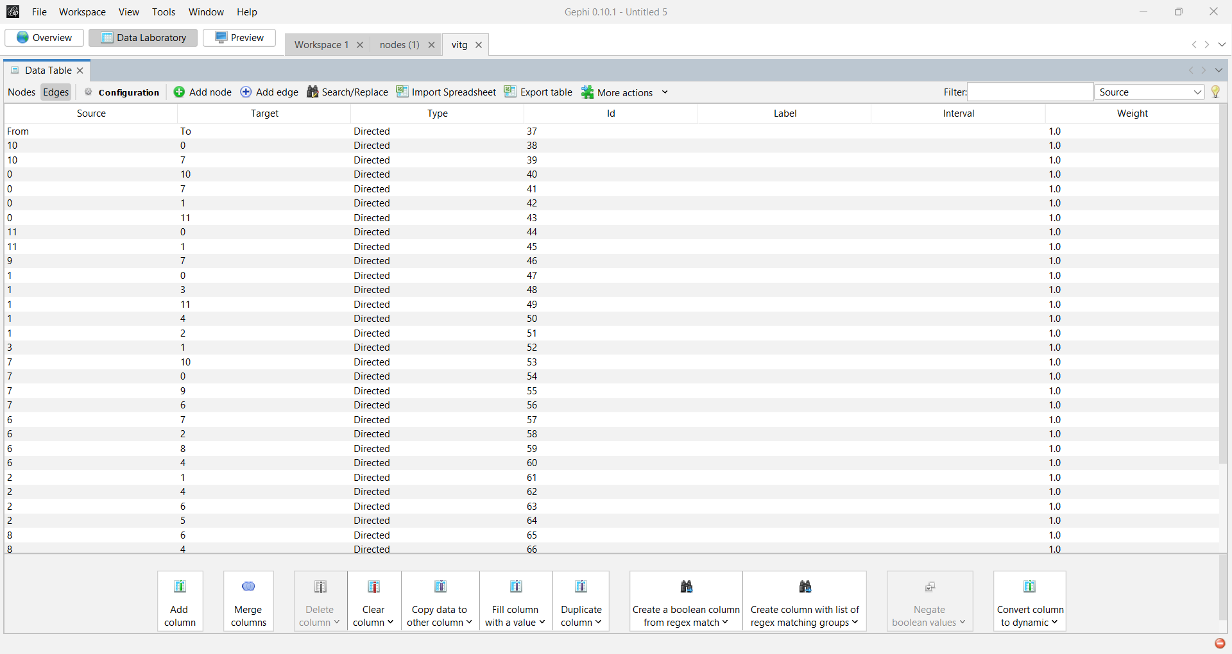

**Overview of the network before processing:**

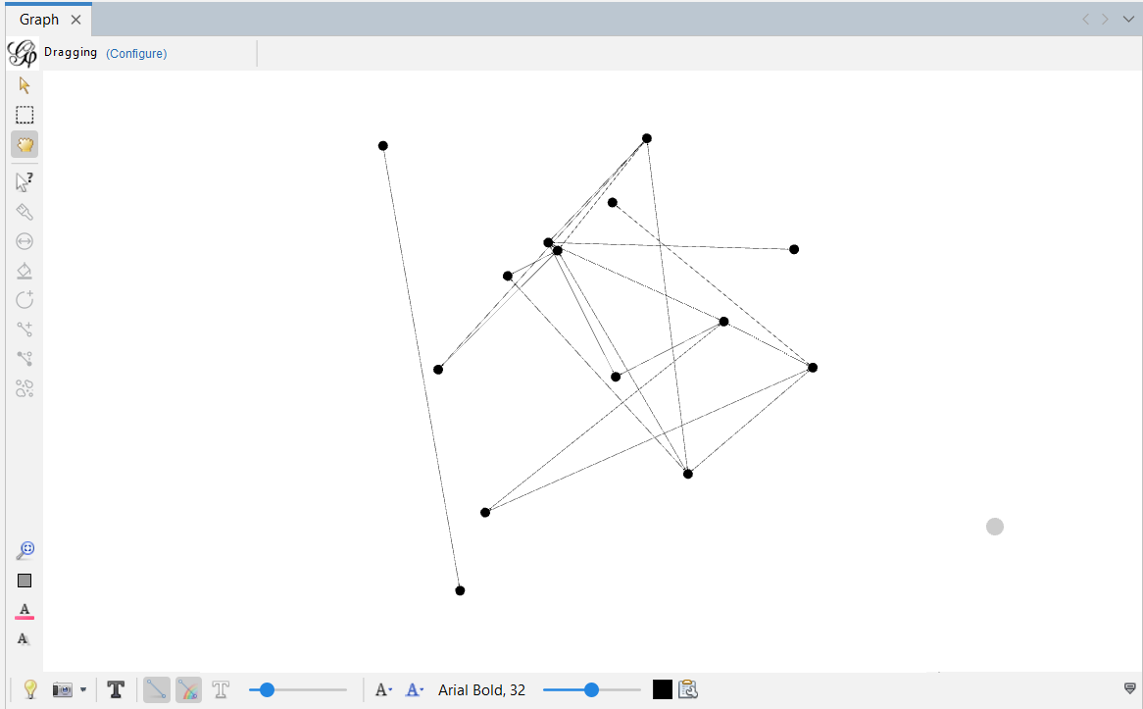

After applying the layout for the network:

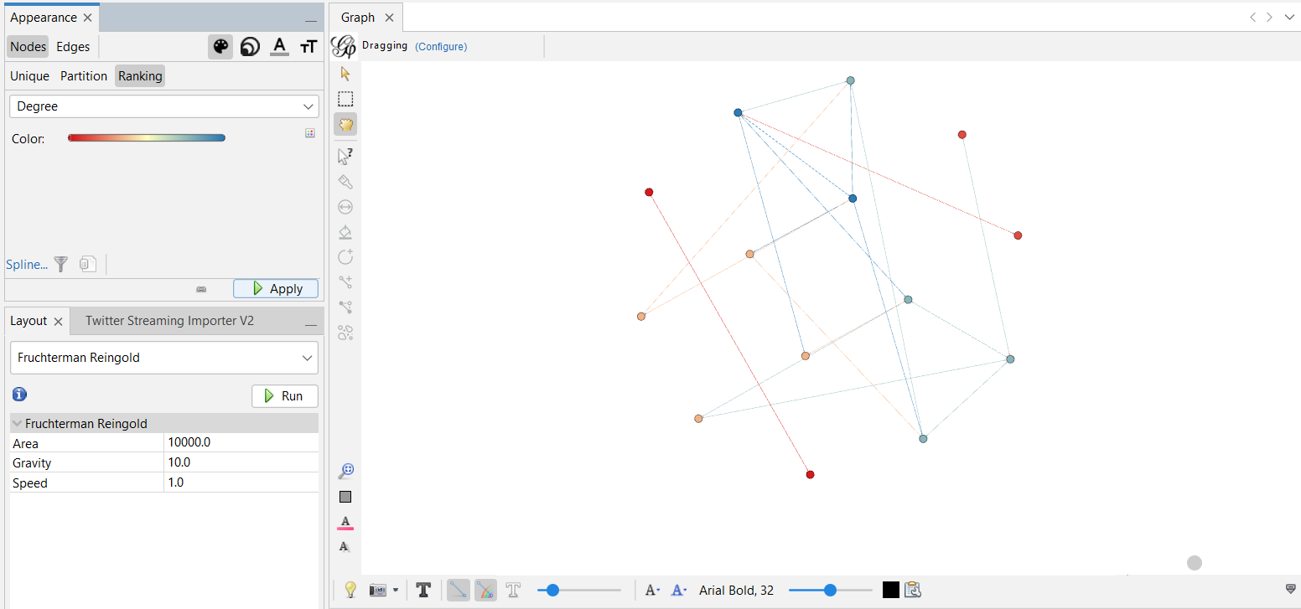

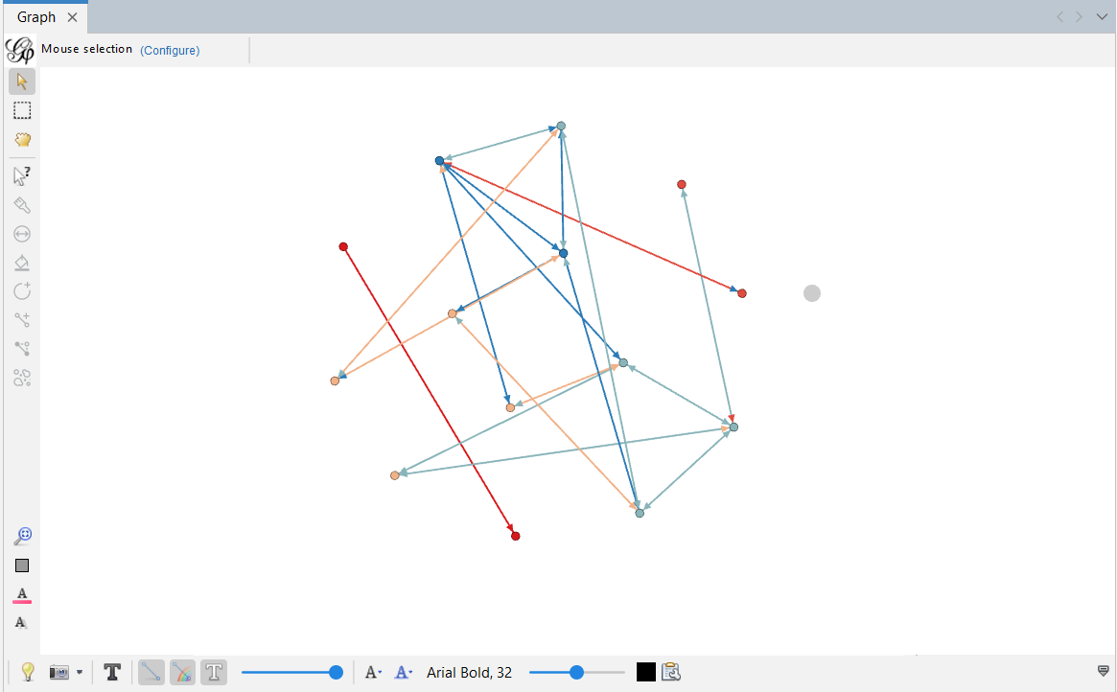

**Degree Report**

**Results:**

Average Degree: 2.643  
  
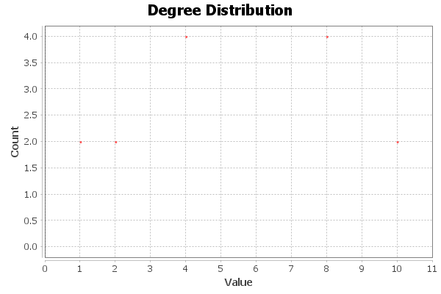  
  
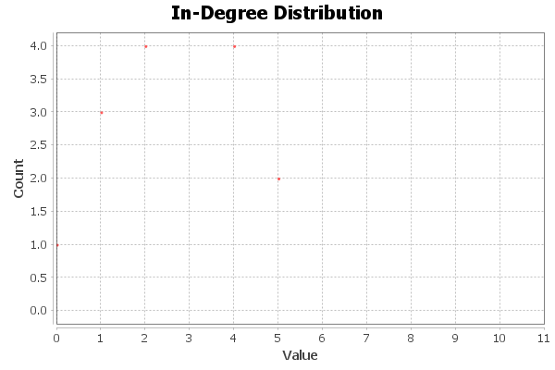  
  
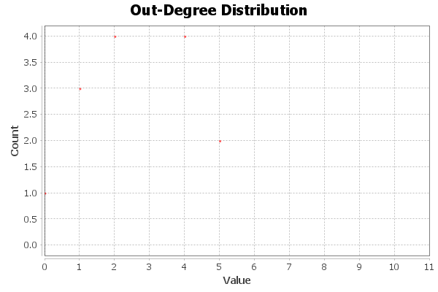

**Weighted Degree Report**

**Results:**

Average Weighted Degree: 2.643  
  
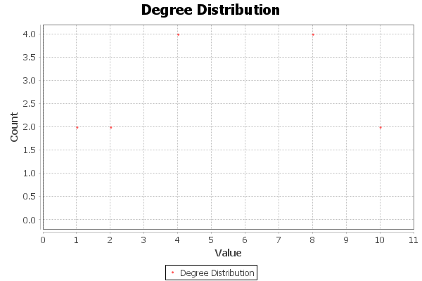  
  
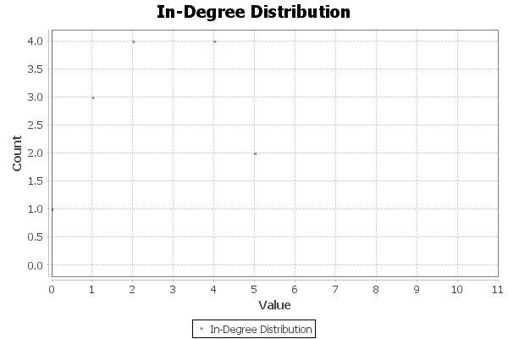  
  
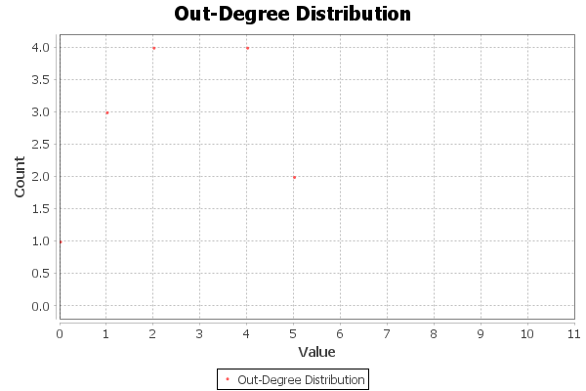

**Graph Distance Report**

**Parameters:**

Network Interpretation: directed

**Results:**

Diameter: 4  
Radius: 0  
Average Path length: 2.0977443609022557  
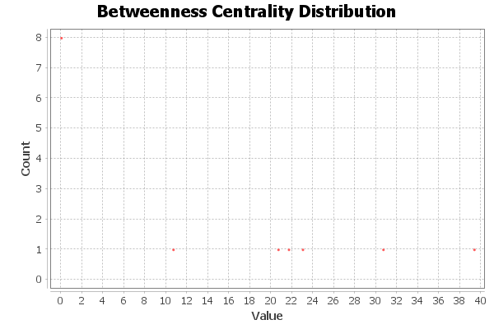  
  
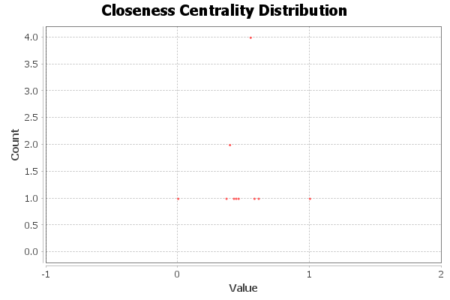  
  
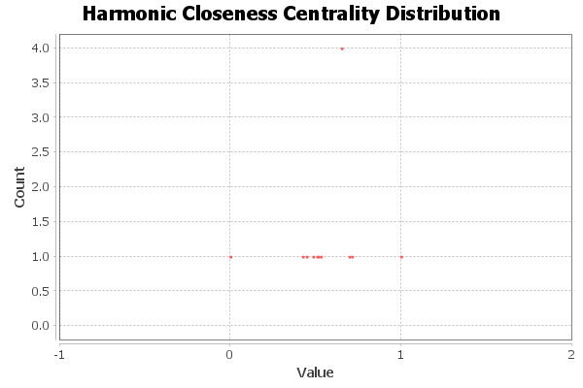  
  
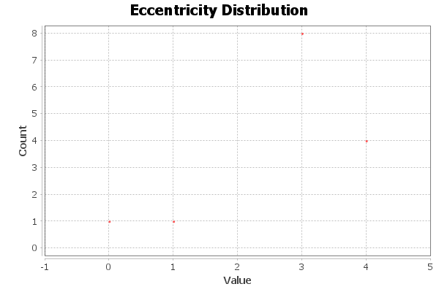

**Algorithm:**

Ulrik Brandes, *A Faster Algorithm for Betweenness Centrality*, in Journal of Mathematical Sociology 25(2):163-177, (2001)

**Graph Density Report**

**Parameters:**

Network Interpretation: directed

**Results:**

Density: 0.203

**Page Rank**

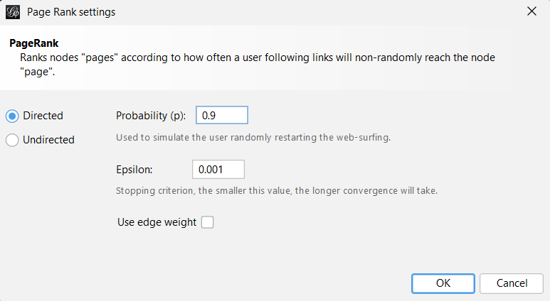

**PageRank Report**

**Parameters:**

Epsilon = 0.001  
Probability = 0.9

**Results:**

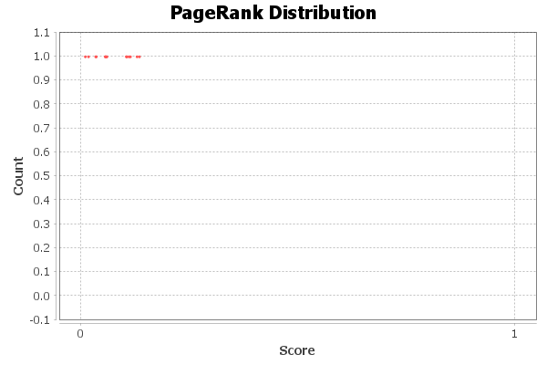

**Algorithm:**

Page, Lawrence and Brin, Sergey and Motwani, Rajeev and Winograd, Terry (1999) *The PageRank Citation Ranking: Bringing Order to the Web.* Technical Report. Stanford InfoLab.

**Modularity Report**

**Parameters:**

Randomize: On  
Use edge weights: On  
Resolution: 1.0

**Results:**

Modularity: 0.406  
Modularity with resolution: 0.406  
Number of Communities: 4  
  
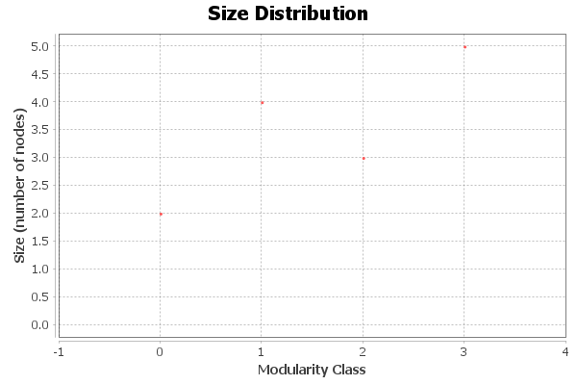

**Algorithm:**

Vincent D Blondel, Jean-Loup Guillaume, Renaud Lambiotte, Etienne Lefebvre, *Fast unfolding of communities in large networks*, in Journal of Statistical Mechanics: Theory and Experiment 2008 (10), P1000

**Resolution:**

R. Lambiotte, J.-C. Delvenne, M. Barahona *Laplacian Dynamics and Multiscale Modular Structure in Networks 2009*

**Statistical Inference Report**

**Results:**

Description Length: 62.173  
Number of Communities: 2  
  
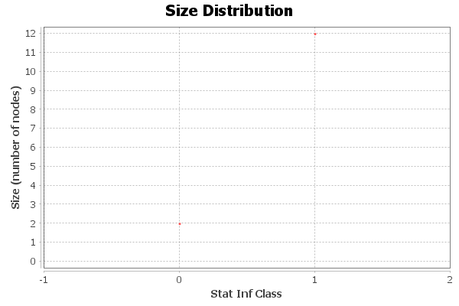

**Algorithm:**

Statistical inference of assortative community structures  
Lizhi Zhang, Tiago P. Peixoto  
Phys. Rev. Research 2 043271 (2020)  
https://dx.doi.org/10.1103/PhysRevResearch.2.043271  
  
  
  
Bayesian stochastic blockmodeling  
Tiago P. Peixoto  
Chapter in “Advances in Network Clustering and Blockmodeling,” edited by  
P. Doreian, V. Batagelj, A. Ferligoj (Wiley, 2019)  
https://dx.doi.org/10.1002/9781119483298.ch11

**Clustering Coefficient Metric Report**

**Parameters:**

Network Interpretation: directed

**Results:**

Average Clustering Coefficient: 0.424  
The Average Clustering Coefficient is the mean value of individual coefficients.  
  
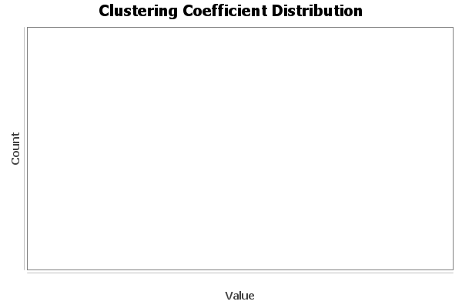

**Algorithm:**

Simple and slow brute force.

**Eigenvector Centrality Report**

**Parameters:**

Network Interpretation: directed  
Number of iterations: 30  
Sum change: 0.005297593535141837

**Results:**

